**COMETBAYCOLLEGE**

**PHYSICS**

**Unit 2 Exam Paper**

**2016**

Student name: ________________________ Teacher name: ______________________

### **Time allowed for this paper**

Reading time before commencing work: Ten minutes

Working time for paper: Two and a Half hours

### **Material required/recommended for this paper**

# To be provided by the supervisor

This Question/answer booklet; Formulae and constants sheet

# To be provided by the candidate

Standard items: pens, pencils, eraser or correction fluid, ruler, highlighter

Special items: scientific non-programmable calculator

# Important note to candidates

No other items may be taken into the examination room. It is **your** responsibility to ensure that you do not have any unauthorised notes or other items of a non-personal nature in the examination room. If you have any unauthorised material with you, hand it to the supervisor before reading any further.

**All calculations are to be set out in detail.** Marks may be awarded for correct equations and clear setting out, even if you cannot complete the calculation. Express **numerical answers** to two (2) or three (3) significant figures and include units where appropriate.

**Student Marks**

|  |  |  |  |  |
| --- | --- | --- | --- | --- |
| **Section** |  | **Maximum mark** | **Student mark Raw** | **Student Scaled Mark** |
| Section One | Short Answer  40% of exam | **58** |  | out of 40 |
| Section Two | Problem Solving  45% of exam | **67** |  | out of 45 |
| Section Three | Comprehension  15% of exam | **22** |  | out of 15 |
| Student Percentage | | | |  |

**Structure of this paper**

|  |  |  |  |  |  |
| --- | --- | --- | --- | --- | --- |
| **Section** | **Number of questions available** | **Number of questions to be answered** | **Suggested working time (minutes)** | **Marks available** | **Percentage of exam** |
| **Section One: Short response** | 14 | all | 60 | 58 | 40 |
| **Section Two: Problem-solving** | 5 | all | 70 | 67 | 45 |
| **Section Three: Comprehension** | 1 | all | 20 | 22 | 15 |
|  |  |  | **Total** | 147 | 100 |

**Instructions to candidates**

1. The rules for the conduct of WACE examinations are detailed in the *Student Information Handbook*. Sitting this examination implies that you agree to abide by these rules.
2. Answer **all** questions in the spaces provided in this Question/Answer Booklet. Answers should be given to the appropriate number of significant figures.
3. A blue or black ballpoint or ink pen should be used.
4. You must be careful to confine your responses to the specific questions asked and to follow any instructions that are specific to a particular question.
5. Spare pages are included at the end of this booklet. They can be used for planning your responses and/or as additional space if required to continue an answer.
   * Planning: If you use the spare pages for planning, indicate this clearly at the top of the page.
   * Continuing an answer: If you need to use the space to continue an answer, indicate in the original answer space where the answer is continued, i.e. give the page number. Fill in the number of the question(s) that you are continuing to answer at the top of the page.
6. When calculating numerical answers, show your working or reasoning clearly. Give final answers to **three** significant figures and include appropriate units where applicable.
7. When estimating numerical answers, show your working or reasoning clearly. Give final answers to a maximum of **two** significant figures and include appropriate units where applicable.

## Section One: Short response 40% (58 Marks)

This section has **fourteen (14)** questions. Answer **all** questions.

Suggested working time: 60 minutes.

## Question 1

In an experiment on scalar and vector quantities, Tony throws a ball 3.20 m east to Rachael. Rachael then throws it 4.50 m west to Sarpreet. Tony then measured the distance and displacement of the ball.

a) Calculate the distance the ball travelled? (1 mark)

**Distance travelled = 3.20 + 4.50 = 7.70 m**

**Distance = 7.70 m (3sig fig) (1 mark)**

b) Draw a vector diagram then determine the ball’s displacement. (3 marks)

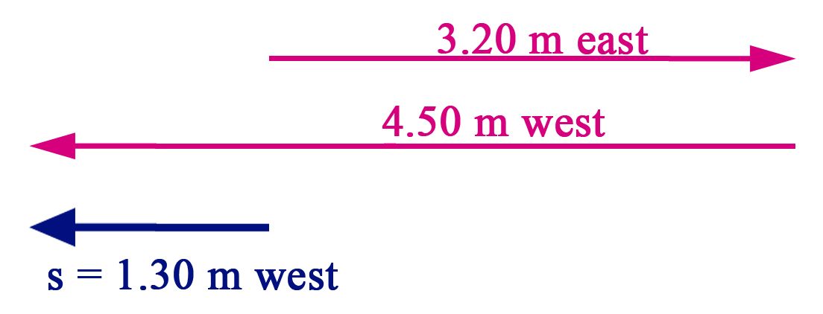**Diagram (1 mark)**

**s = 4.50 – 3.20**

**s = 1.30 m (1 mark) west (1 mark)**

**Question 2**

A 4.10 kg box of books is lifted vertically from rest a distance of 1.60 m by an upward applied force of 60.0 N. Calculate the work done by the applied force. (2 marks)

**W = F x s**

**W = 60.0 x 1.6 (1 mark)**

**W = 96.0 J (1 mark)**

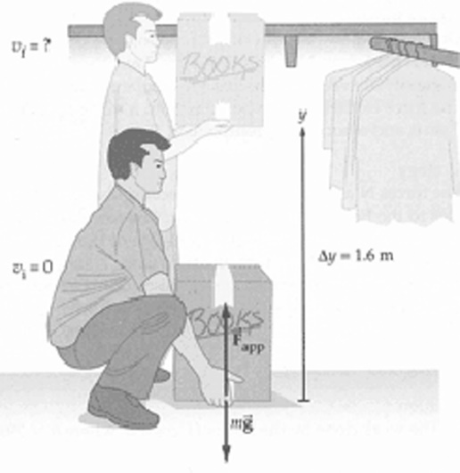

**Question 3**

Blue light has a wavelength of 4.75 x 10-7 m in air. Calculate its frequency in this medium. (2 mark)

**f =**

**f = (1 mark)**

**= 6.32 x 1014 Hz (1 mark)**

**Question 4**

A shooter places the butt plate of a rifle against his shoulder before firing. He fires the rifle and it jerks back into his shoulder causing a bruise. Name the appropriate Law and use physics principles to explain why this happens. (3 marks)

* **Newton’s third Law (1 mark)**
* **For every action force there is an opposite but equal reaction force.**

**(1 mark)**

* **Rifle is fired, gun applies force on the bullet firing bullet forward. At the same time, bullet applies a force on gun pushing gun backwards.**

**(1 mark)**

**Question 5**

A passenger jet took 3.55 hours to travel from one city to another. If the jet travelled at a constant speed of 845 km h-1, calculate the distance the jet travelled. Assume no air resistance. (3 marks)

**time (t) = 3.55 hours**

**= 12780 seconds**

**speed(v) = 845 kmh-1**

**= 234.72 ms-1 (1 mark for converting to m s-1)**

**distance (s) = ?**

**s = v x t**

**= 234.72 × 12780 (1 mark)**

**= 2999750 m**

**Distance = 3.00 × 106 m (3sig fig) (1 mark)**

**Question 6**

Two loudspeakers are set up outside and both emit a single frequency sound in phase. A person walking along a line parallel to the loudspeakers notices that the intensity of sound varies between loud and quiet.

Loudspeaker

Loudspeaker

Person walks along this line

Use physics principles to explain why there are loud regions and quiet regions in this situation. (4 marks)

**In some locations the sound waves from each speaker are arriving in phase. (1 mark)**

**This leads to constructive interference and sound is heard as pressure fluctuates. (1 mark)**

**In some locations the sound waves from each speaker are arriving out of phase by half a wavelength. (1 mark)**

**This leads to destructive interference and no sound is heard as pressure is constant. (1 mark)**

**Question 7**

A theme park ride at the park involves raising a platform, to which the riders are strapped, to a height of 30.0 m. The platform is then allowed to free-fall until it is brought to a rapid stop near the ground. The ride has to decelerate at a rapid 12.4 m s-2 just before it reaches the ground.

a) As the ride decelerates to a halt, do you expect the occupants to feel; (1 mark)

CIRCLE the correct answer

LIGHTER HEAVIER THE SAME

b) If the riders and platform have a mass of 2.60 x 103 kg what would be the apparent weight of rider and platform as the platform decelerates to a halt. (Include a diagram)

(3 marks)

**m = 2600 kg**

**a = 12.4 ms-2**

**g = 9.8 ms-2**

**Fw = m(a + g) (1 mark)**

**= 2600 (12.4 + 9.8) (1 mark)**

**= 2600 × 22.2**

**Fw = 5.77 × 104 N (1 mark)**

Fa

Fg

**Question 8**

A squash player hits the ball at a speed of 35.0 m s-1 at an angle of 300 to the side wall of the court. The ball rebounds at 900 to the original direction at a speed of 27.5 m s-1. Draw a vector diagram and calculate the vector change in velocity? Use a scaled vector diagram. (5 marks)

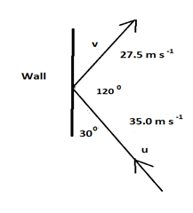

**44.51 m s-1**

**90o**

90o

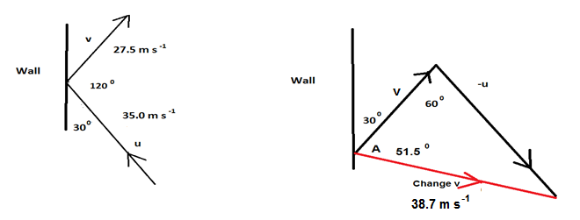

**Diagram (Δv** **= v – u)**  **(1 mark)**

**Δv** **= ([-u]2 + v2)0.5 (Trig) (1 mark)**

**Δv** **= 44.51 m s-1 (1 mark)**

**tan A = 35**

**27.5 (1 mark)**

**A = 51.80**

**Δv** **= 38.7 m s-1 at N81.8oE (1 mark)**

**Question 9**

The average power supplied by an adult’s heart for circuiting blood is about 1.5 watts.

a) How much work does an adult human heart do in one hour? (2 marks)

**P = 1.5 W, t = 1 hr = 3600 s (1 mark)**

**E = P × t = 1.5 × 3600 = 5400 J (1 mark)**

b) If this amount of work is used to lift a 50.0 kg object with a constant velocity, what is the theoretical maximum height to which the object can be raised? Use an energy value of 5000 J if you were unable to determine an answer for (a). (3 marks)

**f = 6.32 x 1014 Hz (1 mark)**

**λ = x 4.75 x 10-7 = 3.17 x 10-7 m (1 mark)**

**Question 10**

A student was performing some experiments on a standing wave using a cathode ray oscilloscope. He collected the following data. Draw two graphs (displacement/time and displacement/distance) to represent the following information of the wave.

1. The screen on a cathode ray oscilloscope showed four full waves.
2. The dot producing the waves moved across the screen in 0.200 seconds.
3. The wavelength was determined to be 0.500m
4. The amplitude of the wave was 0.250 m

On these graphs label the period, amplitude and wavelength.

a) Displacement/time (3 marks)

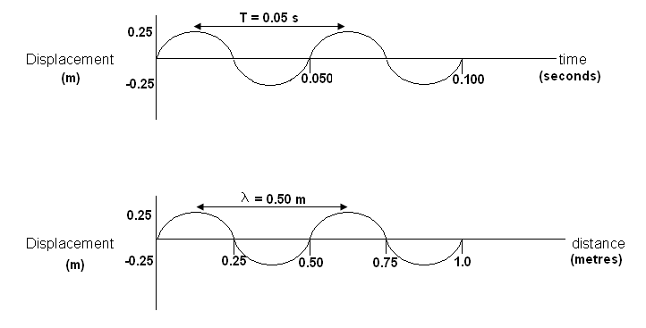

**Shows 4 waves (1 mark)**

**Correct amplitude (1 mark each wave)**

**Correct wavelength (1 mark)**

**Correct time (1 mark)**

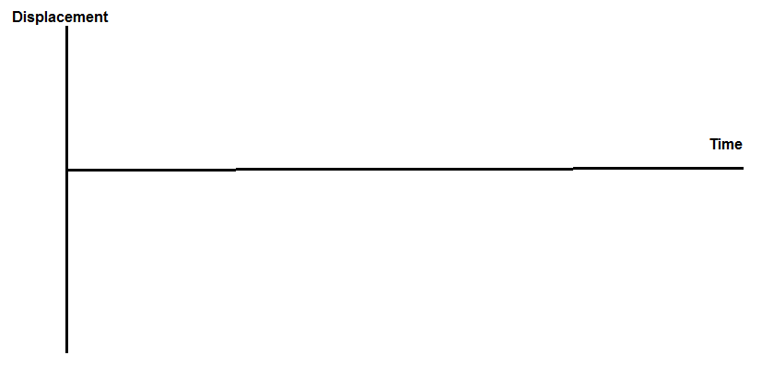

b) Displacement/distance (3 marks)

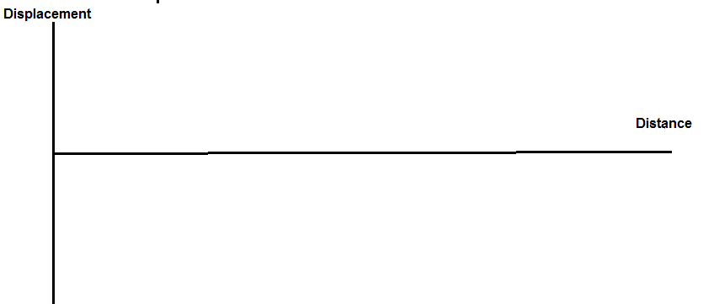

**Question 11**

When a parachutist opens his parachute his velocity immediately drops to 4.80 m s-1.

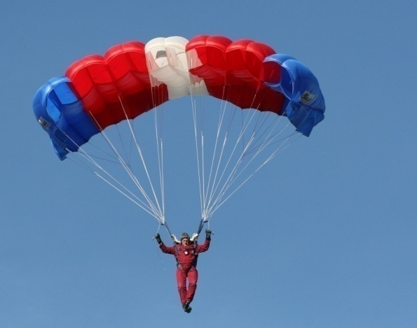

a) Use the image below to draw a free body diagram showing the force(s) acting on him. (1 mark)

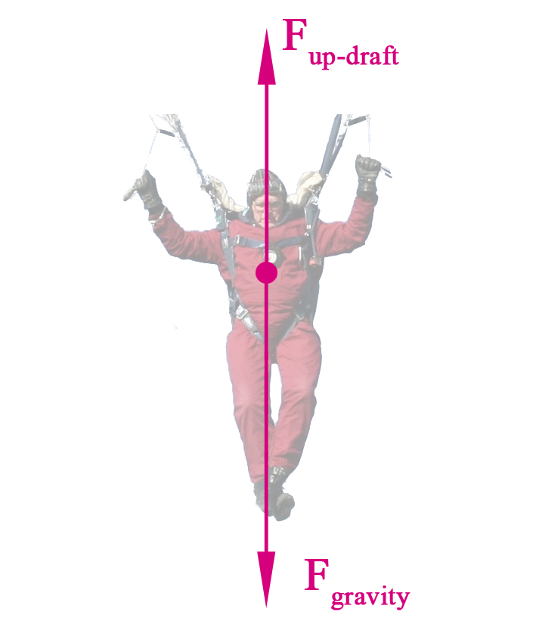

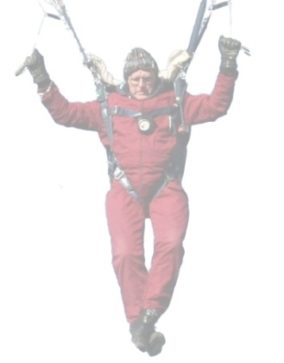

b) At a point 1.48 × 103 m above the ground he is still travelling at 4.80 m s-1, when he hits a thermal which is an updraft of air. This updraft is occurring at 1.84 m s-1 in the opposite direction to his descent. This upwards current of air continues during the entire descent.

i) Calculate the parachutist’s resultant initial velocity due to the updraft. (2 marks)

**vT = v1 + v2**

**vT = 4.80 + -1.84 (1 mark)**

**vT = 2.96 m s-1 (down) (1 mark)**

ii) How long does it take the parachutist to reach the ground with the thermal affecting the decent, assuming his velocity remains constant throughout the descent? (2 marks)

**Down as positive**

**s = 1.48 × 103 m t = = (1 mark)**

**u = 2.96 m s-1  = 500 seconds (1 mark)**

**Question 12**

A crude musical instrument can be made by tying several lengths of hollow metal tube together as shown in the diagram below. When a performer gently blows across the tops of the tubes, musical notes are produced.



For all parts of this question assume the performer blows with the same strength of breath.

a) If all the tubes are of equal diameter, which tube would you expect to produce the note with the highest fundamental frequency? Explain your answer. (2 marks)

**The tube with the shortest length would produce the highest frequency note. (1 mark)**

**The wavelength of the fundamental note would be smaller in the short tube compared to the others. Using v = f λ, if c is a constant and λ is small then the value of f will be greater. (1 mark)**

b) If the performer blocked the bottom end of the middle tube would you expect it to produce the same fundamental note as the open tube? Explain your answer.

(2 marks)

**The note would be a different frequency. (1 mark)**

**By blocking the tube it is now a closed pipe so the wavelength of the note will be altered. In this case the wavelength is 4 times the length of the tube. (1 mark)**

**Question 13**

1. A violin string is 0.65 m in length. Sketch the standing waves produced and determine the wavelengths of the 1st and 2nd harmonics. (4 marks)

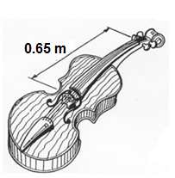

1st HarmonicWavelength = ________

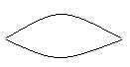 **(1 mark)**

**Wavelength = 1.3 m (1 mark)**

2nd HarmonicWavelength = ________

 **(1 mark)**

**Wavelength = 0.65 m**

b) If the wave speed on the string is 400 m s-1, calculate the frequencies of the first two harmonics? (3 marks)

**f = 1 mark**

**1st f = (1 mark) 1 mark**

**2nd f = 2 × 308 (1 mark)**

**= 615 Hz (1 mark) 1 mark**

**Question 14**

When sound waves travelling through water meet a boundary with air there will be some reflection and some refraction. Complete the diagram by showing how the wavefronts behave. You should draw four wavefronts for each case. (The dotted line is a ‘normal’ which is a geometrical reference line at 90° to the boundary) (4 marks)



Air

Water

## Section Two: Problem-solving 45% (67 Marks)

This section has **five (5)** questions. Answer **all** questions. Write your answers in the spaces provided.

Suggested working time: 70 minutes.

**Question 1**

The diagram shows an air column that is resonating because a standing wave has formed inside it. A small microphone can slide inside the pipe without interfering with the standing wave. The microphone has detected loud regions and regions with no sound associated with this standing wave.



Loud sound

No sound

Loud sound

No sound

Air Column

1. Sketch the standing wave envelope for pressure variation within this air column.

(1 mark)

1. Explain briefly why there are loud regions and regions with no sound. (2 marks)

**Sound waves are travelling along the pipe and reflecting from each end.**

**The standing wave is an interference pattern of the incident waves and reflected rays.**

**Loud spots are points of constructive interference and no sound heard at points of destructive interference. (Or similar)**

**NOTE: Antinodes – maximum displacement of particles**

**NOTE: Nodes – minimum displacement of particles**

1. The air column has an effective length of 36.0 cm. The speed of sound in air is 346 m s-1. Calculate the frequency of this standing wave. (3 marks)

**¾ λ = 0.36 m (1 mark) f = (n v) / (4 L)**

**λ = 0.480 m n = 3 (1 mark)**

**f = v / λ = 346 / 0.480 (1 mark) f = (3 x 346)/(4 x 036) (1 mark)**

**= 721 Hz (1 mark) f = 721 Hz (1 mark)**

1. Calculate the frequency produced by the air column if it were vibrating in its fundamental mode. (2 marks)

**¼ λ = 0.36 m**

**λ = 1.44 m**

**f = v / λ = 346 / 1.44 (1 mark)**

**= 240 Hz (1 mark)**

**Question 2**

A cricket ball with a mass of 160.0 g is travelling horizontally with a velocity of 28.0 m s-1 when it strikes another player’s helmet. The balls impact time was 0.500 x 10-3 s.

a) Determine the total impulse the ball delivers to the helmet? (3 marks)

**m = 0.16 kg**

**u = 28.0 m s-1**

**t = 0.5 x 10-3 s**

**v = 0**

**Impulse = Ft = m(v – u) F = (1/2 mark)**

**= 0.16 x (0 – 28) (1 mark)**

**= -4.48 Ns**

**Impulse = 4.48 Ns (of kg m s-1) (1 mark)**

**in opposite direction to initial motion. (1 mark)**

1. Calculate the ball’s acceleration on hitting the helmet? (3 marks)

**a = (1 mark)**

**= −56000 ms-2**

**= 5.60 × 104 ms-2 (1 mark)**

**Decelerating (1 mark)**

c) Calculate the average force the ball exerts on the helmet? (3 marks)

**F = ma**

**= 0.160 x -56000 (1 mark)**

**= -8960 N**

**F = 8.96 x 103 N in opposite direction to initial motion. (2 marks)**

d) Determine the work done on the ball by the helmet to bring it to a halt? (3 marks)

**u = 28 ms-1**

**v = 0**

**v2= u2 +2as s = ut + ½at2**

**0=282+(2 × −5600 × s) (1 mark) =28 × 0.5 × 10-3 + ½ × -5.6 × 104 × (0.5 × 10-3)2**

**0 = 784 – 112000s = 7.0 × 10-3 m**

**s = 7.0 × 10-3 m (1 mark)**

**W = Fs Ek = ½ mv2**

**= 8960 × 7.0 × 10-3  = ½ × 0.16 × 282**

**W = 62.7 J (1 mark) = 62.7 J**

**Question 3**

A BMX rider was testing the limits of his new bike before a big race. The graph below shows his movements.

**D**

**C**

**F**

**E**

**B**

1. Explain (in detail) what he was doing during the testing of his bike in relation to the displacement, velocity and acceleration (no calculations required). (3 marks)

**Stationary for the first 6 seconds at the origin**

**Accelerates from t = 6 sec to t = 11 sec**

**Constant velocity from t = 11 sec to t = 19 sec**

**Decelerates from t = 19 sec to t = 24 sec**

**Stationary from t = 24 sec to t = 30 sec, 78 metres from origin**

**(minus ½ mark for each missing underlined section)**

Use the graph to determine the following information:

1. (i) How far did he travel in the 30 seconds? (1 mark)

**78 m (± 1 m) (1 mark)**

1. For how long was the BMX biker stationery? (1 mark)

**12 seconds (± 1 s) (1 mark)**

1. Calculate the velocity (m s-1) in the following segments:
2. Line CD (show on the graph information that supports the calculations)

(3 marks)

**v = s .**

**t**

**= 57 – 21 . (1 mark)**

**18 – 12**

**= 6 m s-1  (1 mark)**

**lines shown on graph (1 mark)**

1. Point B (1 mark)

**0 m s-1 (as starting from stationary, so initial velocity is zero) (1 mark)**

1. Point C (1 mark)

**6 m s-1 (1 mark)**

1. Point D (1 mark)

**6 m s-1 (1 mark)**

1. Point E (1 mark)

**0 m s-1 (as starting from stationary, so initial velocity is zero) (1 mark)**

1. Draw a graph of velocity versus time. (5 marks)

**Minus 1 mark if missing any of the following;**

|  |  |
| --- | --- |
| * **Detailed Title (includes independent and dependent variables)** * **Time on x-axis** * **x-axis scaled correctly** * **Labels** * **Units to labels** * **Scale of graph is as large as possible on the page** | * **Line graph** * **Points plotted correctly for 0 – 6 sec** * **Points plotted correctly for 6 – 11 sec** * **Points plotted correctly for 11 – 19 sec** * **Points plotted correctly for 19 – 24 sec** * **Points plotted correctly for 24 – 30 sec** |

**Question 4**

A roller-coaster is 17.0 m high at its highest point, the release point A. The diagram below is a simple representation of the first part of the ride.



a) The car is released from a stationary position at A and has no independent locomotion (no engine). Indicate the direction of the car’s acceleration in each of the following regions by circling the correct answer.

(i) Car moving from A to B? (1 mark)

CIRCLE the correct answer: **A up slope down slope**

(ii) Car moving from C to D? (1 mark)

CIRCLE the correct answer: **A to B up slope down slope**

(iii) Car moving from E to F? (1 mark)

CIRCLE the correct answer: **A to B up slope down slope**

b) If the length of track between A and B is 21.0 m and the car is released from rest at A and reaches a velocity of 18.5 m s-1 at B, what is the magnitude of the acceleration it experiences between A and B? (4 marks)

**v = 18.5 m s-1 v2 = u2 + 2as**

**u = 0 (1 mark) a = (1 mark)**

**s = 21 m a = 8.15 (1 mark) m s-2 (1 mark)**

c) If the car just makes it to point C, what proportion (fraction or percentage) of the energy has been lost as heat? (3 marks)

**Ep = mgh,**

**Energy lost is Ep (at A) – Ep (at C)**

**Mass and gravity are constant, hence Ep proportional to height (1 mark)**

**Change in h = 17 – 13 = 4 m (1 mark)**

**percentage lost = =0.235 (1 mark)**

**(accept 23.5% for ½ mark)**

d) In relation to this energy lost as heat, how is it generated and where does it go? (3 marks)

**Kinetic Energy (1 mark)**

**Friction generates heat → main cause of energy loss (1 mark)**

**Very small amount to sound, light (sparks?) and wear (deformation) Heat lost to tracks and air. (1 mark)**

e) Will the velocity of the car be greater at point B or point D? Give a reason for your answer. (2 marks)

**Will be greatest at B (1 mark)**

**Earlier in the ride = less heat loss therefore same height EK is greater at B.**

**(½ mark)**

**Height between A→B greater than C→D. (½ mark)**

**Question 5**

A 1500 kg car is travelling east at 15.0 m s-1 when it crashes into a 4500 kg truck travelling in the opposite direction at 12.0 m s-1. The car has a velocity of 6.0 m s-1 in the opposite direction it was initially travelling after the collision.

Assuming this is an inelastic collision, determine:

1. The speed of the truck just after the collision (4 marks)

**Δpbefore = Δpafter**

**positive to the cars initial direction (1 mark for vector)**

**m1u1 + m2u2 = m1v1 + m2v2**

**1500 × 15 + 4500 × -12 = 1500 × -6 + 4500 × v2 (1 mark)**

**v2 = -5 m s-1 (1 mark)**

**v2 = 5 m s-1 in the same direction it was initially travelling (1 mark)**

1. How much kinetic energy is lost during the collision? What is this kinetic energy converted into? (6 marks)

**ΣEKbefore ≠ ΣEKafter (½ mu12 + ½ mu22 ≠ ½ mv12+½ mv22)**

**ΣEKbefore = ½× 1500 × 152 + ½ ×4500 × 122 (1 mark)**

**= 168750 + 324000**

**= 492750 J (1 mark)**

**ΣEKafter=½ ×1500 × 62 – ½ ×2500 × 52 (1 mark)**

**= 27000 + 56250**

**= 83250 J (1 mark)**

**EKloss= 492750 J – 83250J**

**= 409500 J (1 mark)**

**The kinetic energy is converted into heat and/or sound (1 mark)**

1. The following graph shows the cars on-board computer data output of the accident. This was used to analysis and determine the impact during the first 0.35 seconds of the collision between the car and the truck, before the car rebounded. This is used to help design safer cars in the future by understanding the forces experienced during the collision. Assuming the person strapped into the car experiences the full force of impact that the car itself experiences, calculate the force the person in the car would experience during the final 0.2 seconds of the collision. (5 marks)

**p = F t**

**F = p / t (1 mark recognising gradient)**

**Coordinates (0.15,2000) & (0.35,0) (1 mark or shown on graph)**

**F = 2000 – 0 (1 mark)**

**0.15 – 0.35**

**F = -13333.3 N**

**F = 1.33 x 104 N (1 mark)**

**in opposite direction to car initially travelling (1 mark)**

|  |  |  |
| --- | --- | --- |
| **Section Three: Comprehension** |  | **15% (22 Marks)** |

This section has **one (1)** question. You must answer **every part** in the question. Write your answers in the spaces provided.

Spare pages are included at the end of this booklet. They can be used for planning your responses and/or as additional space if required to continue an answer.

* + - Planning: If you use the spare pages for planning, indicate this clearly at the top of the page.
    - Continuing an answer: If you need to use the space to continue an answer, indicate in the original answer space where the answer is continued, i.e. give the page number. Fill in the number of the question that you are continuing to answer at the top of the page.

Suggested working time: 20 minutes.

**Question 1**

**How Safe is Your Car**

**Crash Protection Features**

Crash protection features provide greater levels of injury protection to drivers and passengers in car crashes, they include:

**Crumple zones**

Modern cars protect drivers and passengers in frontal, rear and offset crashes by using crumple zones to absorb crash energy. This means that the car absorbs the impact of the crash, not the driver or passengers.

**Strong occupant compartment**

The cabin of the car should keep its shape in frontal crashes to protect the driver and passenger’s space. The steering column, dashboard, roof pillars, pedals and floor panels should not be pushed excessively inwards, where they are more likely to injure drivers and passengers. Doors should remain closed during a crash and should be able to be opened afterwards to assist in quick rescue, while strong roof pillars can provide extra protection in rollover crashes.

**Side impact protection**

Increased side door strength, internal padding and better seats can improve protection in side impact crashes. Most new cars have side intrusion beams or other protection within the door structure. Some cars also have padding on the inside door panels.

Increasingly, car manufacturers are installing side airbags that provide protection from severe injury. Head-protecting side airbags, such as [curtain airbags](http://www.howsafeisyourcar.com.au/Curtain-Airbags/), are highly effective in side impact and rollover crashes.

[**Seat belts**](http://www.howsafeisyourcar.com.au/Safety-Features/Safety-Features-List/Seatbelt-Pretensioner-Driver/)

A properly worn seat belt provides good protection but does not always prevent injuries. Three point lap/sash seat belts offer superior protection to two point seat belts and should be installed in all seating positions. Recent improvements to seat belt effectiveness include:

* webbing clamps that stop more seat belt reeling out as it tightens on the spool
* pretensioners that pull the seat belt tight before the occupant starts to move
* load limiters that manage the forces applied to the body in a crash
* seat belt warning systems to remind you if seat belts have not been fastened.

[**Airbags**](http://www.howsafeisyourcar.com.au/Safety-Features/Safety-Features-List/Front-Airbags-Driver/)

Australian airbags are designed to supplement the protection provided by seat belts - they are not a substitute. The best protection in frontal crashes is achieved using a properly worn seat belt in combination with an airbag.

[**Head rests**](http://www.howsafeisyourcar.com.au/Safety-Features/Safety-Features-List/Head-Restraints-All/)

Head rests are important safety features and should be fitted to all seats - front and back. Head rest position is critical for preventing whiplash in rear impact crashes. Whiplash is caused by the head extending backward from the torso in the initial stage of rear impact, then being thrown forward. To prevent whiplash the head rest should be at least as high as the head's centre of gravity (eye level and higher) and as close to the back of the head as possible.

Diagram and Information courtesy of Folksam Research, 2005 (SWEDEN)

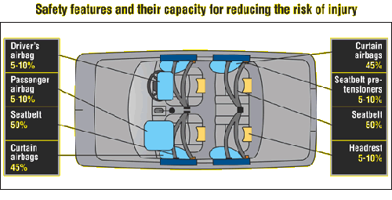

1. “Modern cars protect drivers and passengers in frontal, rear and offset crashes by using crumple zones to absorb crash energy.” (2 marks)

Explain the energy transformations that occur when a car’s crumple zone absorbs energy in a crash.

**EK of car (1 mark)**

**is converted to noise, heat and deforming (1 mark)**

1. Crumple zones also reduce the force experienced when a car crashes. Explain, using Newton’s Second Law (momentum) how this acts as an additional safety feature in a car. (4 marks)

**Newton’s Second Law commonly written as F = ma 1 mark**

**Can be rewritten as F = (mv – mu)/t 1 mark**

**t increases 1 mark**

**F decreases, hence less force on occupants 1 mark**

**Or similar**

1. Two point seat belts are belts that fit across the driver’s or passenger’s lap. The two points were generally on the floor. Modern car seat belts have a third point about shoulder height when sitting. Why is this advantageous? (2 marks)

**Better at keeping occupant in place 1 mark**

**Prevents body/head for going forward and hitting something 1 mark**

1. You are in the passenger seat holding a 3.00 kg parcel on your lap. Your car (mass of 1200 kg) is involved in a head on crash with a tree. The car speed goes from 72.0 km h-1 to zero in 0.100 s. What force is required to hold the parcel? (3 marks)

**m = 3 kg v = 0 t = 0.100 s**

**u = 72.0 km h-1 = 72/3.6 = 20 m s-1 1 mark**

**F = (mv- mu)/t = (3 x 0 – 3 x 20)/0.100 1 mark**

**F = 6.00 x 102 N 1 mark**

1. During the accident, how much energy is absorbed by the car? (2 marks)

**Find Energy**

**v = 0 m = 1200 kg**

**u = 72.0 km h-1 = 72/3.6 = 20 m s-1**

**Ek = ½ m v2**

**= ½ x 1200 x (-20)2 1 mark**

**= 2.4 x 105 J 1 mark**

1. Head rests reduce whiplash injuries in car crashes. Identify and use the appropriate Newton’s Law to explain why this is so. (3 marks)

**Whiplash is generally caused by crashes where the person is in the vehicle hit from behind 1 mark**

**According to Newton’s First Law the unrestrained head continues forward and then body “jerks” it back 1 mark**

**The head rest reduces how far back the head can snap back 1 mark**

1. Airbags inflate and then deflate very quickly. Why? (2 marks)

**Inflate quickly to prevent head hitting solid object 1 mark**

**Deflate quickly to prevent suffocation 1 mark**

1. If the accident mentioned above was a “side-on” impact. That is, you were in a stationary vehicle that was hit on the passenger’s side by a vehicle travelling at 72 km h-1. Then using scientific explanations and calculations, discuss how much more or less significant of an accident would you consider it to be? (4 marks)

**Assumption on more or less is not worth any marks unless there is a reasonable explanation to follow 1 mark**

**According to Newton’s First Law the unrestrained body/head continues in one direction and then it “jerks” back the other way due to the seatbelts 1 mark**

**Curtain airbag has 45% capacity for reducing the risk of injury, whereas front air bag only has a 5 – 10% capacity for reducing the risk of injury 1 mark**

**Hence the curtain airbag is 4.5 to 9 times more effective. With this alone the side impact is less significant of an accident 1 mark**

**END OF EXAM**

**Acknowledgements**

Question 23 – How Safe Is Your Car?

Reprinted with permission from the Transport Accident Commission of Victoria and Folksam Research of Sweden

**SPARE PAPER**

QUESTION ______ :



QUESTION ______ :

QUESTION ______ :

________________________________________________________________________________________________________________________________________________________________________________________________________________________________________________________________________________________________________________________________________________________________________________________________________________________________________________________________________________________________________________________________________________________________________________________________________________________________________________________________________

QUESTION ______ :

QUESTION ______ :

________________________________________________________________________________________________________________________________________________________________________________________________________________________________________________________________________________________________________________________________________________________________________________________________________________________________________________________________________________________________________________________________________________________________________________________________________________________________________________________________________

QUESTION ______ :

QUESTION ______ :

________________________________________________________________________________________________________________________________________________________________________________________________________________________________________________________________________________________________________________________________________________________________________________________________________________________________________________________________________________________________________________________________________________________________________________________________________________________________________________________________________

QUESTION ______ :